FDB OptimiseRX
Update from the Medicines Management Team

Optimise Rx is an important part of the medicines optimisation strategy designed to deliver key quality and cost savings messages at the point of prescribing where the team cannot. The MMT actively manages the profile to try to increase the value of the system to practices. This bulletin highlights some trends we have noticed, messages with high levels of rejection and suggests steps practices can take to increase relevance of the system. The MMT continue to adjust the profile and deactivate less useful prompts.
Optimise Rx is now in its second year. Recently the acceptance level of messages has fallen to 15% with the industry average being around 21.5%. (Details of each practices acceptance rates are below)
Optimise Rx takes into account the full patient’s history (as Read coded), messages are offered based on evidence based best practice, safety and cost.
Current messages are reviewed and new messages are added to ensure the most up to date national guidance and local formulary guidance is offered.
We would like to encourage that all prescribers consider accepting the messages listed or update patients read codes to avoid inappropriate messages being offered.
Contents
Best Practice Message Highlights 1
Best Practice Message – Graphs per locality 2
Cost Message Highlights 3
FDB Medication Review Button (S1 only) 4
Contact us 4

Best Practice Message Highlights

Message | Rationale | Recommended Action
Aspirin: not recommended for primary prevention of cardiovascular events in the absence of other valid indications | This message is only presented when the patient is over 16 years not recorded as pregnant, prescribed antiplatelet aspirin (formulation strength less than or equal to 150mg) within 2 months, without a valid alternative indication: ischaemic heart disease, myocardial infarction, prosthetic heart valve, transient ischaemic attack, stroke, peripheral arterial disease (including retinal occlusions), carotid endarterectomy, polycythaemia rubra vera. | Aspirin is not licensed for primary prevention of cardiovascular disease. If an appropriate Read code is added where the patient has an alternative indication, this message will not be offered.
Message | Rationale | Recommended Action
 | NICE Clinical Knowledge Summaries (CKS) on Antiplatelet Treatment states that antiplatelet treatment should not be routinely prescribed for the primary prevention of cardiovascular disease. There is no evidence that clinical benefits (reduction in systemic emboli) outweigh the harms (increase in major haemorrhagic events). Aspirin is no longer recommended for prevention of stroke in patients with atrial fibrillation, as per NICE Guidance for the treatment of atrial fibrillation (CG180, June 2014).
Oral mucolytic: not recommended to prevent exacerbations in COPD | This message is presented for patients with COPD, who have been prescribed oral mucolytics.  The message is triggered because the patient record has neither a chronic cough within 2 years, nor productive cough within the last 90 days. | Where appropriate a Read Code should be added to the patient record for chronic cough. This will avoid the message being presented for patients inappropriately.
Mefenamic acid: not recommended first line for analgesia | This message is presented for patients aged 10 years and over, prescribed mefenamic acid, not prescribed ibuprofen (excluding topical or parenteral routes) within the last 13 months, or not prescribed naproxen within the last 13 months if aged 15 years and over. | The NHS Regional Drug and Therapeutics Centre bulletin (January 2014) states that mefenamic acid should not be a first-line choice for analgesia (including dysmenorrhoea), as there is no evidence that mefenamic acid is more effective than other NSAIDs.

Best Practice Message – Graphs per locality
The graphs below show the detail of each GP Practices hit count (number of messages offered) and acceptance rate for best practice messages over the last 3 months. Increasing your acceptance will improve quality prescribing and optimise cost efficiencies.
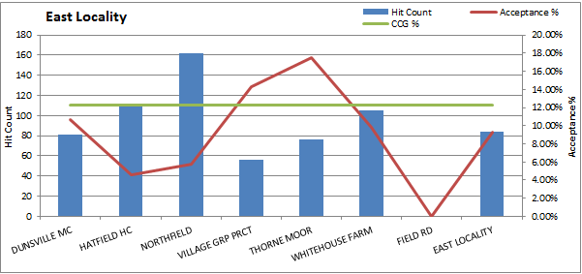
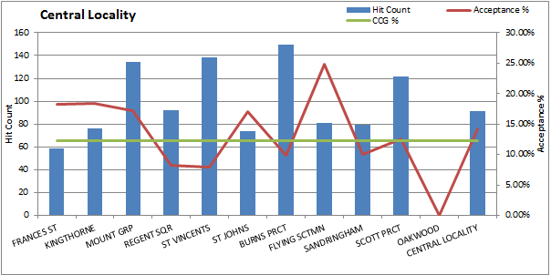

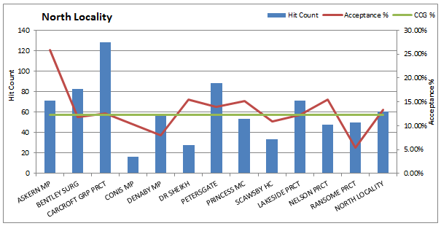
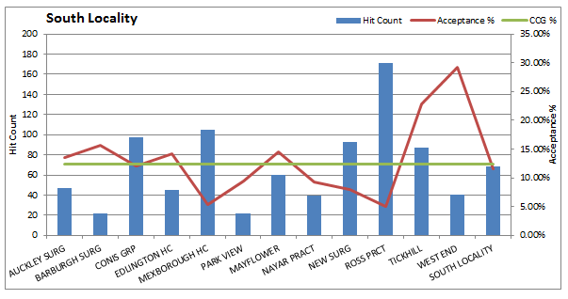

Cost Message Highlights
Optimise Rx has made £107,895 in actual savings from April 2018 to August 2018. The chart below shows details of cost saving messages where, if accepted, significant savings could have been made. The total of the missed savings for Quarter 1 18/19 in these 5 messages alone is £27,739

 | Hit count (number of times the message was offered) | Reject (number of times message was rejected) | Potential Savings Missed
Tiotropium 18microgram (10microgram delivered) inhalation powder capsules (with device and refill pack; brands, generic): consider swapping to Braltus (tiotropium) 10microgram inhalation powder capsules with device | 427 | 392 | £9279
Felodipine 24-hour modified-release tablets (brands, generics): consider swapping to amlodipine tablets | 706 | 461 | £8027
Pregabalin 75mg capsules (brands only): consider swapping to generic pregabalin 75mg capsules | 22 | 19 | £3754
Dutasteride 500microgram capsules: consider swapping to finasteride 5mg tablets | 128 | 103 | £3428
Metformin 1000mg modified-release tablets (brands and generic): consider swapping to metformin 500mg immediate-release tablets | 432 | 268 | £3251

FDB Medication Review Button (S1 only)
Currently available on SystemOne only, the FDB button is a useful tool, especially for complex multi-morbidity and polypharmacy patients, to allow prescribers to identify opportunities for optimising all current prescriptions for any given patient. The patients’ record is reviewed against all Optimise Rx messages and will return the results in a summary window.
Details of how to add and use the FDB button can be found on the medicines management website in the User Guide for SystemOne http://medicinesmanagement.doncasterccg.nhs.uk/guidelines/. The Emis Web Optimise Rx user guide can also be found here.

Contact us
If you have any queries, comments or concerns regarding Optimise Rx and the messages that are offered please contact the medicines management team via DONCCG.Medicinesmanagementadmin@NHS.net
You can also use this address if you have any suggestions for new messages or feedback for the current messages offered. Your feedback is read and acted upon by our working group who actively maintain the profile each fortnight.

