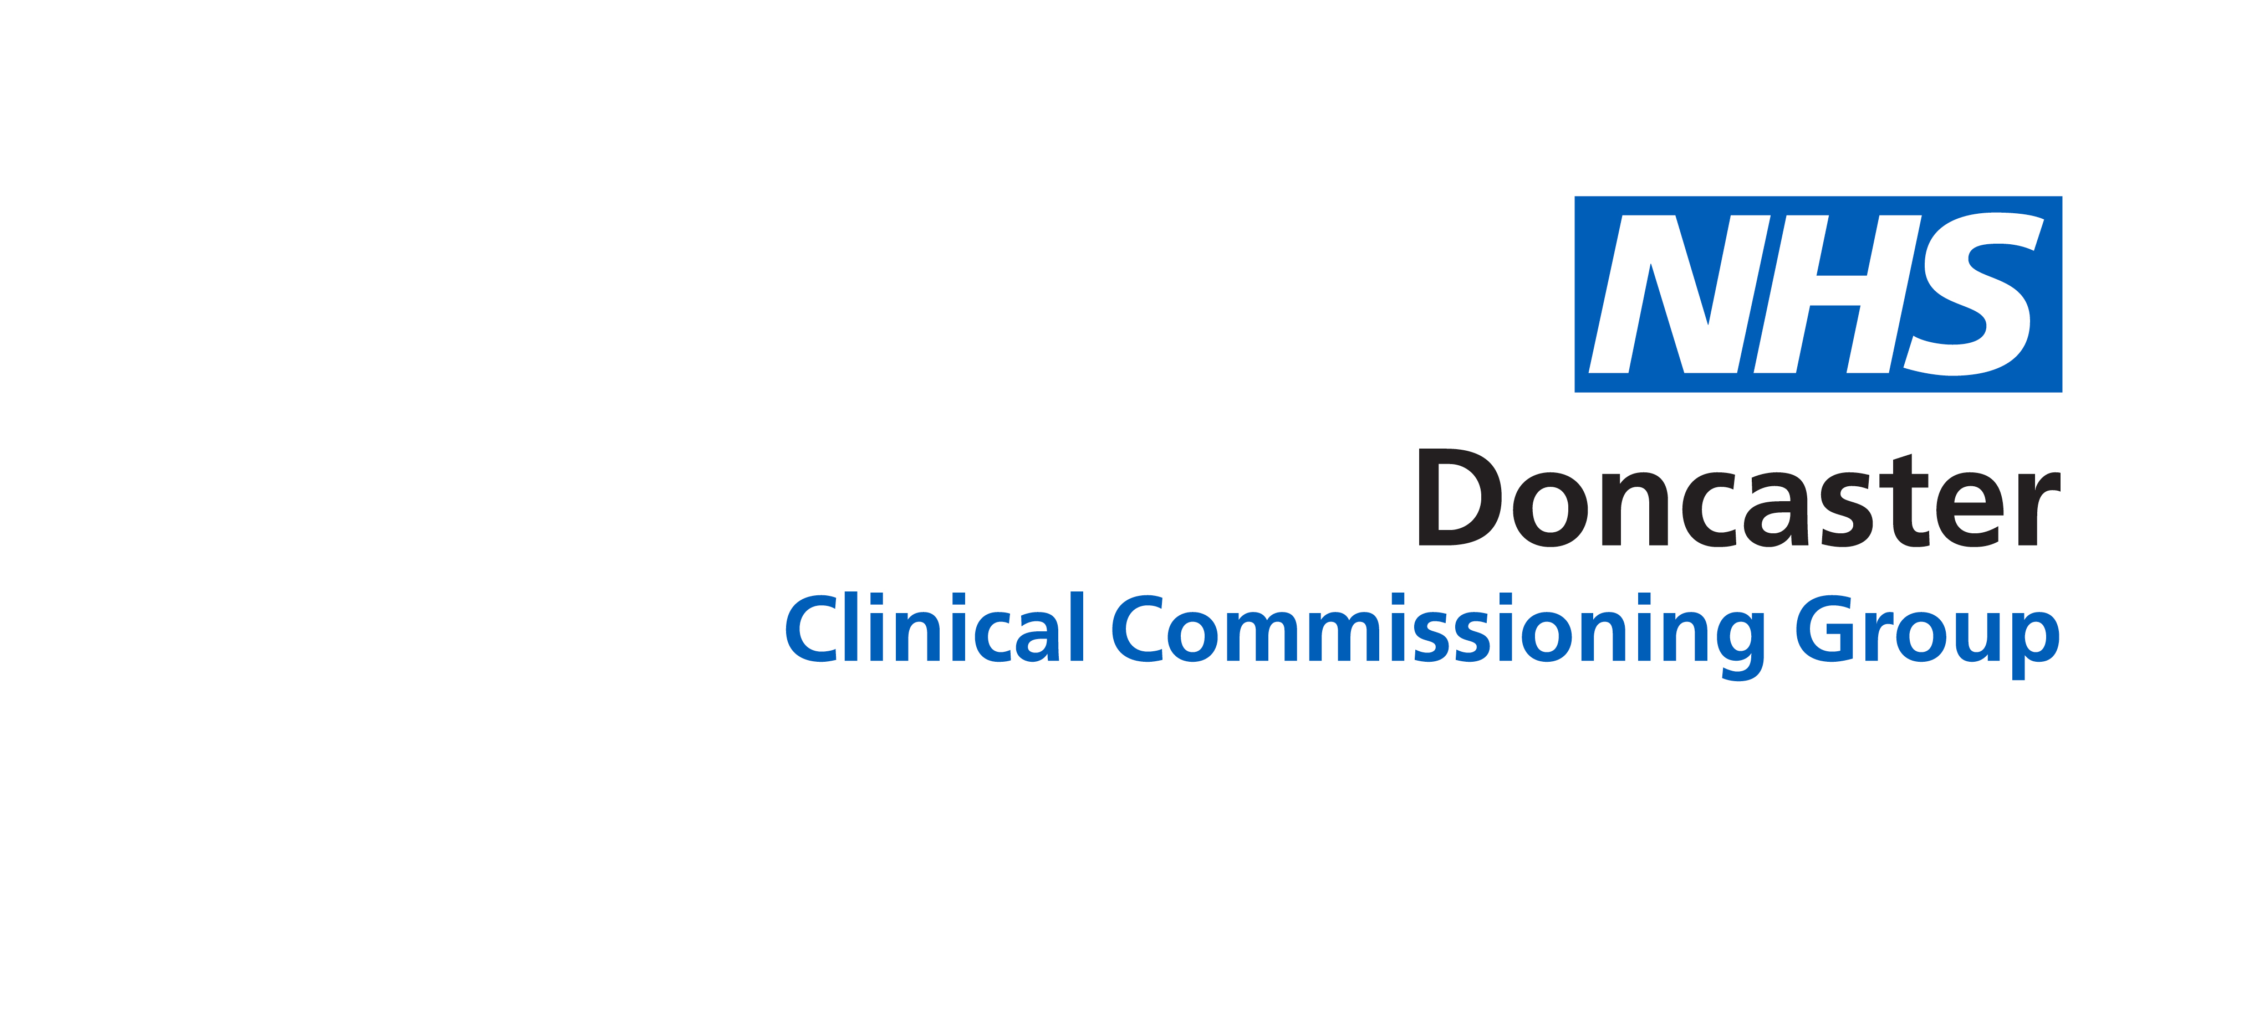

Process for dealing with requests from Pharmaceutical Industry for appointment with Head of Medicines Management and/or GP Prescribing Lead

The aim of this process is to provide a fair, open and consistent approach to dealing with requests from the Pharmaceutical Industry.
Process:
- Complete the electronic form
- Return completed form to DONCCG.MedicinesManagementAdmin@nhs.net
- Non-completion or partial completion of the form will result in the request not being considered.
- The request will be considered by the CCG Head Of Medicines Management/CCG Prescribing Lead
- A reply will be entered on the form and returned by email.

1. Date of submission of request

2. Name of person submitting request

3. Telephone contact details

4. Email contact details

5. Pharmaceutical company details

6. Generic Drug Name/Disease area

7. Brand Drug Name/Disease area

8. BNF Therapeutic classification

9. Licensed indication for use

10. Current cost of product to NHS*

£ per month £ per annum £ per treatment course

11. Provide details of names and costs of similar drugs against which your product would be reasonably compared *

* Please be aware that lack of details for Q10 & 11 may lead to your request not being considered

12. How does this request support any the commissioning priorities for Doncaster?

13. How does this request support the NHS patient experience agenda?

14. How does this request support the NHS improvement of quality agenda?

For completion by Medicines Management Team – delete as appropriate †

†Your request for an appointment has been declined. The reason for this is:
- Non/partial completion of the form
- Your request does not fulfil the commissioning priorities for the CCG
- Other- details provided …………..

† Further details are required prior to a decision being made regarding an appointment. The details are as follows:

† Your request for an appointment has been accepted. You will be contacted shortly to arrange this.

