Standard Operating Procedure for
Doncaster CCG Non-Medical Prescriber Registration,
Deletion or amendment
AIM
To ensure the NHS Business Services Authority registration, deletion or amendment of all Doncaster GP Practice Non-Medical Prescriber (NMP) requests is completed effectively for NMPs working within NHS Doncaster.

RESPONSIBILITY
It is the responsibility of the NMP and their manager to contact the Medicines Management Team (MMT) to request registration, deletion or amendment and then complete the appropriate forms correctly and return to the MMT.

It is the responsibility of the MMT staff to respond to any NMP registration requests in a timely manner, and then undertake the registration process detailed below effectively.

PROCEDURE
If you are a:
- Healthcare professional who has recently gained the Non-Medical Prescriber qualification or
- The manager of a newly qualified NMP or
- The manager of a NMP who is recently employed by your organisation

You will need to submit a request to NHS Doncaster Clinical Commissioning Groups (CCG) Medicines Management Team to register the NMP with the NHS Business Services Authority (NHSBSA) (previously known as the PPA).

To submit a request the following steps below must be undertaken:

- Select and complete the appropriate NHS BSA form embedded below, either:
- the registration /notification form for a NMP joining the practice
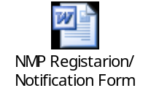
- the deletion form for a NMP leaving the practice
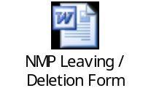
- or amendment form for a NMP Change of details
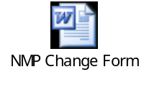
- Complete the NMP Employer Declaration


- Email the Medicines Management Team medicinesmanagementadmin@doncasterccg.nhs.uk requesting they process the NMP registration with NHSBA. Alternatively you can fax the forms to 01302 556321.

- Ensure both the completed NMP Manager Checklist form and the appropriate NHSBSA form are attached to the email.

- You will be copied in to an email sent to the NHS Business Services from either Joanne Sanderson or Gill Bradley, your request to register, delete or amend a Non-Medical Prescriber will now be processed:
- The prescriber details will be registered within 3 working days. You will not receive any notification from the NHS Business Services Authority when this is completed.
- You can now add the prescriber to your practice IT system (should you need any assistance to undertake this process please contact the Business System Support services on 01302 566565)

- If a prescription pad is required please request this via the Primary Care Support England portal http:pcse.england.nhs.uk/

A prescription pad will then be delivered in the next 4-6 weeks.
For any queries about prescription pads please contact Primary Care Support England Email: PCSE.enquiries@nhs.net
Tel: 0333 0142 884
Fax: 0113 277 6912

- If a British National Formulary (BNF) is required please contact Binley’s the BNF distributors via email: bnf@binleys.com including the following details in the email:
- Request to receive copy of BNF (or & BNFc)
- Prescriber’s Name
- Prescriber’s Registration Number e.g NMC or GPhC No.
- Delivery Address

