NHS Doncaster Clinical Commissioning Group
Medicines Management Team

Outline of the process for the recording of Medication prescribed by Secondary/Tertiary care onto GP Clinical Support Systems.

Background

This document has been developed as a result of identifying the risks to patients receiving medication prescribed by any prescriber other than their regular GP. If such medication is not documented on a patient’s record on the GP clinical system there is a high level of risk regarding drug-interactions, contra-indications and side effects. A recurring example of this is with the prescribing of trimethoprim to patients who are already receiving methotrexate from secondary care. As a consequence of the methotrexate not being documented on the GP clinical system for information the relevant drug-interaction is not highlighted during the prescribing of the trimethoprim, and may lead to the patient being exposed to the risk from the drug-interaction.

The situation is not isolated to methotrexate and trimethoprim, and may be a potential problem with any medication that is being prescribed and supplied by a prescriber other than the patients regular GP.

Purpose

This document provides guidance of how the two clinical systems operated by practices in the Doncaster area can be used to ensure that medication classified as Red and Amber (until a shared care agreement is arranged) under the NHS Doncaster and Bassetlaw Traffic Light System are documented in a patient’s medication record to ensure any safety alerts are generated when prescribing a new medication.

GP clinical systems used in Doncaster Practices

Emis Web
Systm1

This document provides guidance to include medication for information to both clinical systems.

Emis Web
- Access patient care record on the clinical system
- Navigate to medication screen
- Click ‘Add a drug’

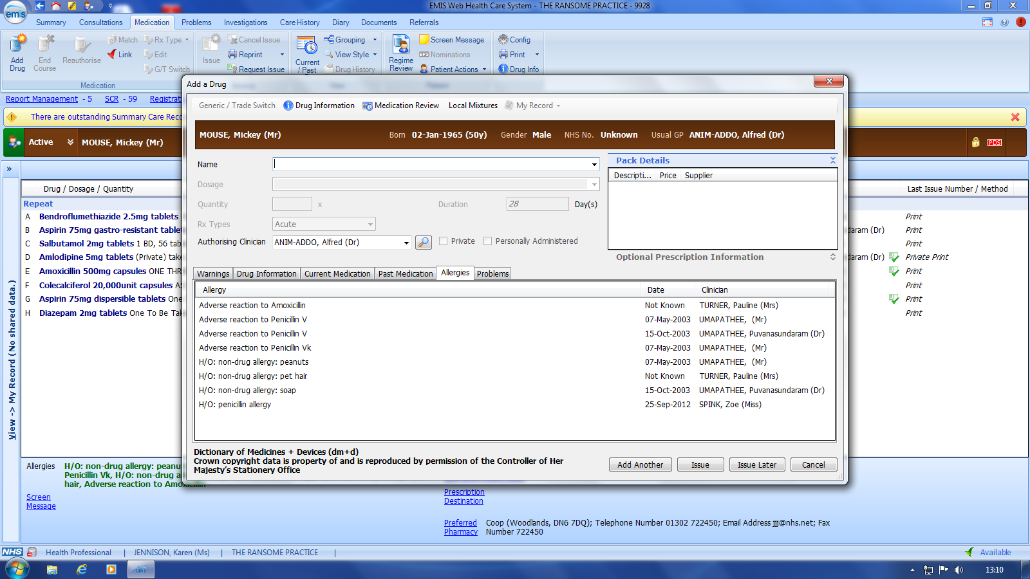

- Find drug on formulary, add directions if needed and 0.1 tablet. You can write in the pharmacy Info box – Hospital only prescription DO NOT ISSUE if you wish (not necessary but optional )

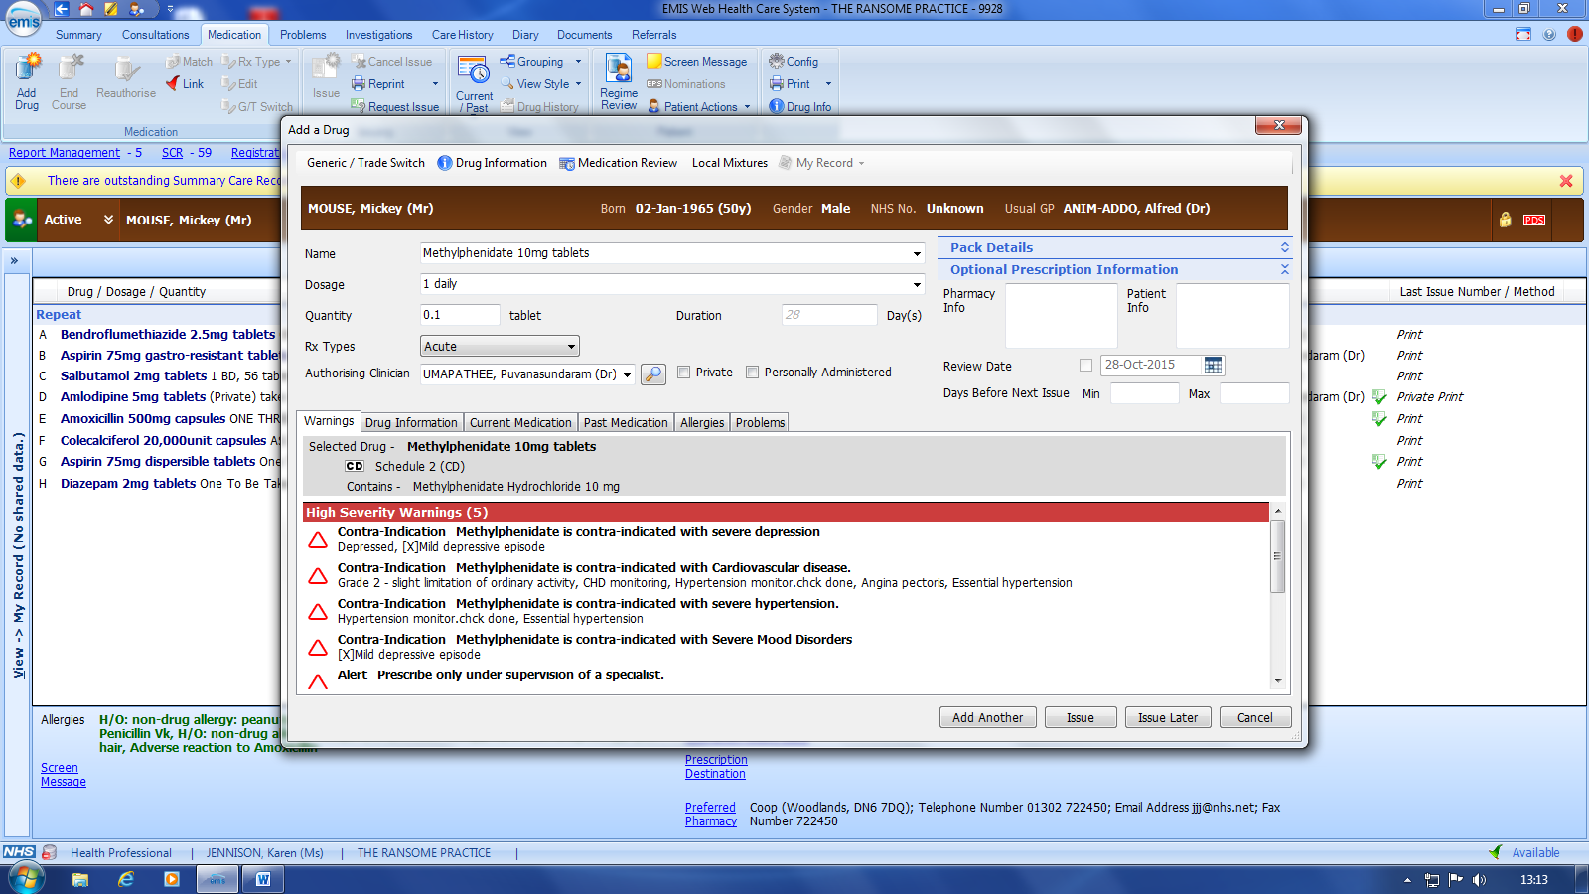

- Add as acute prescription

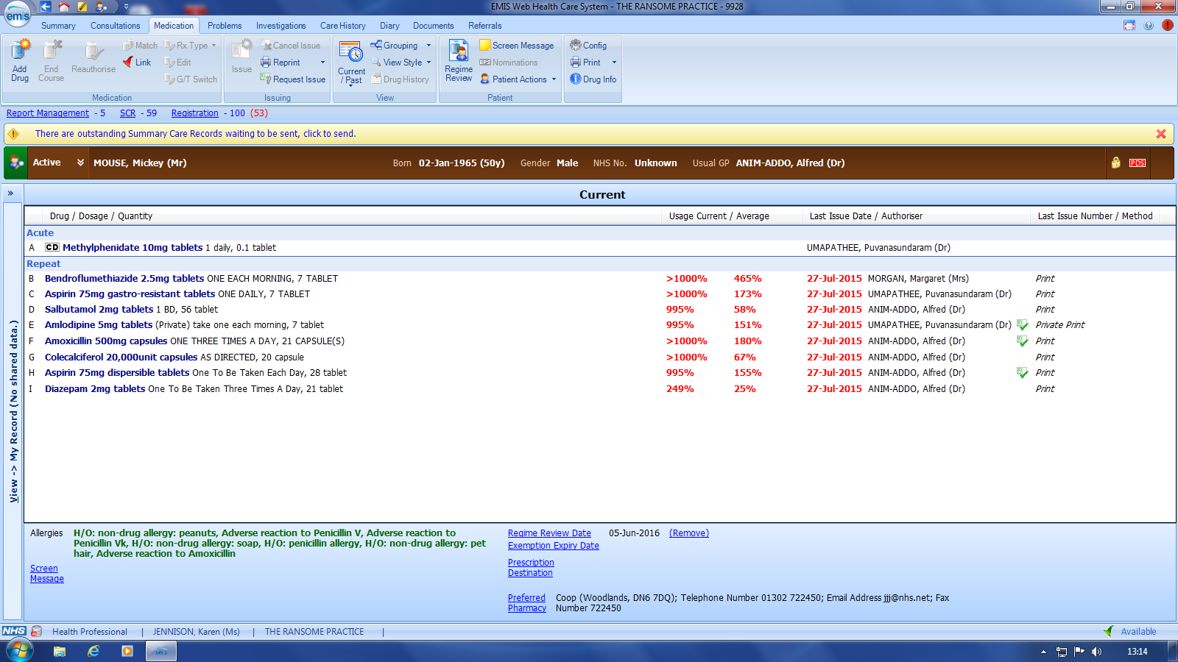

- Click Issue

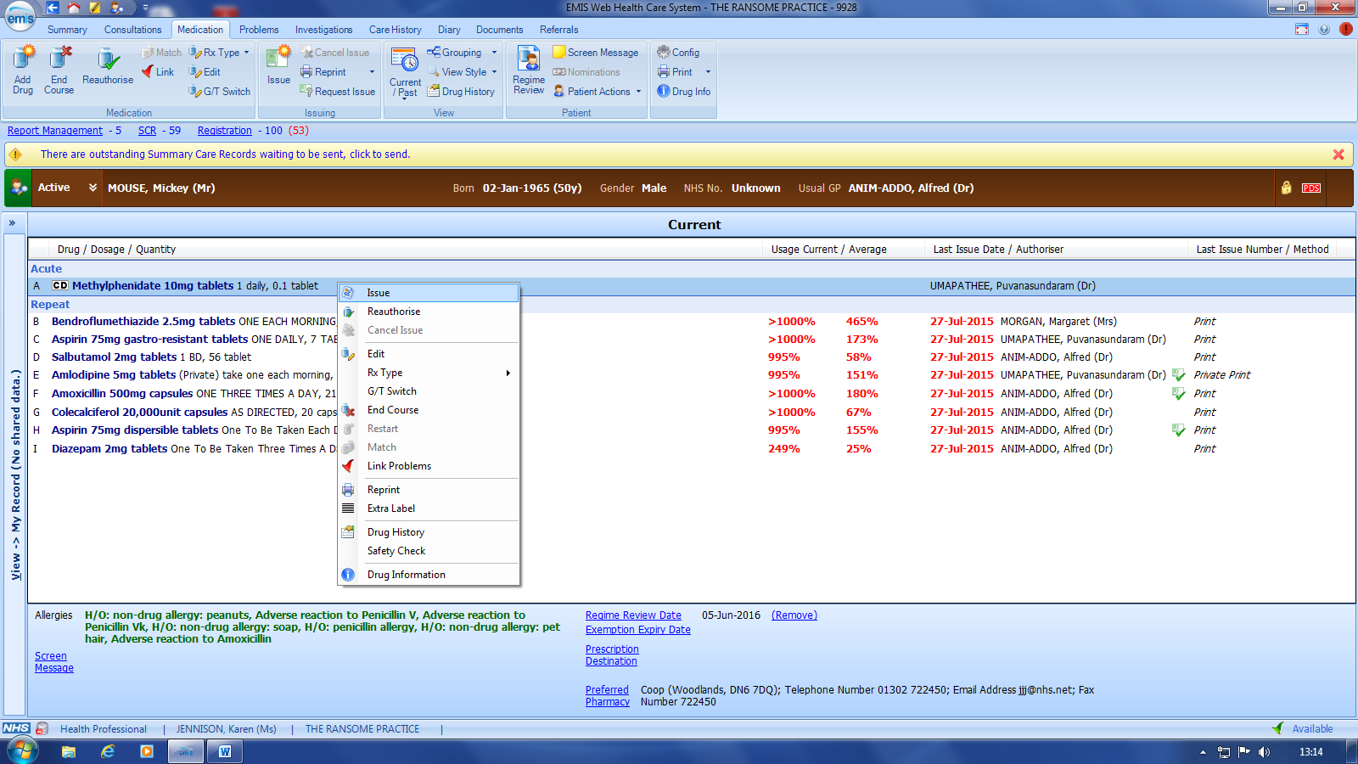

- Click change all

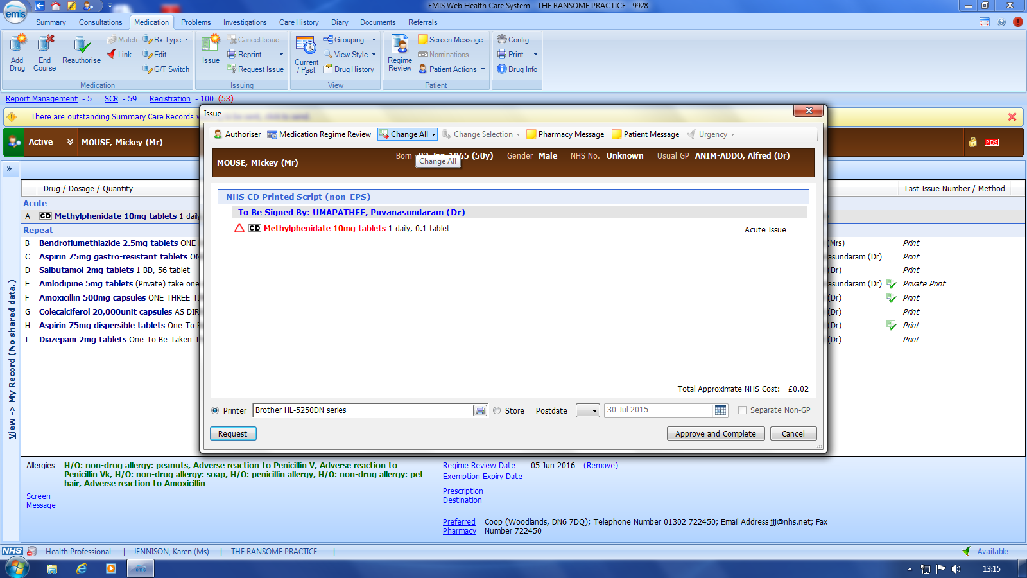

- Click Hospital (no Print)

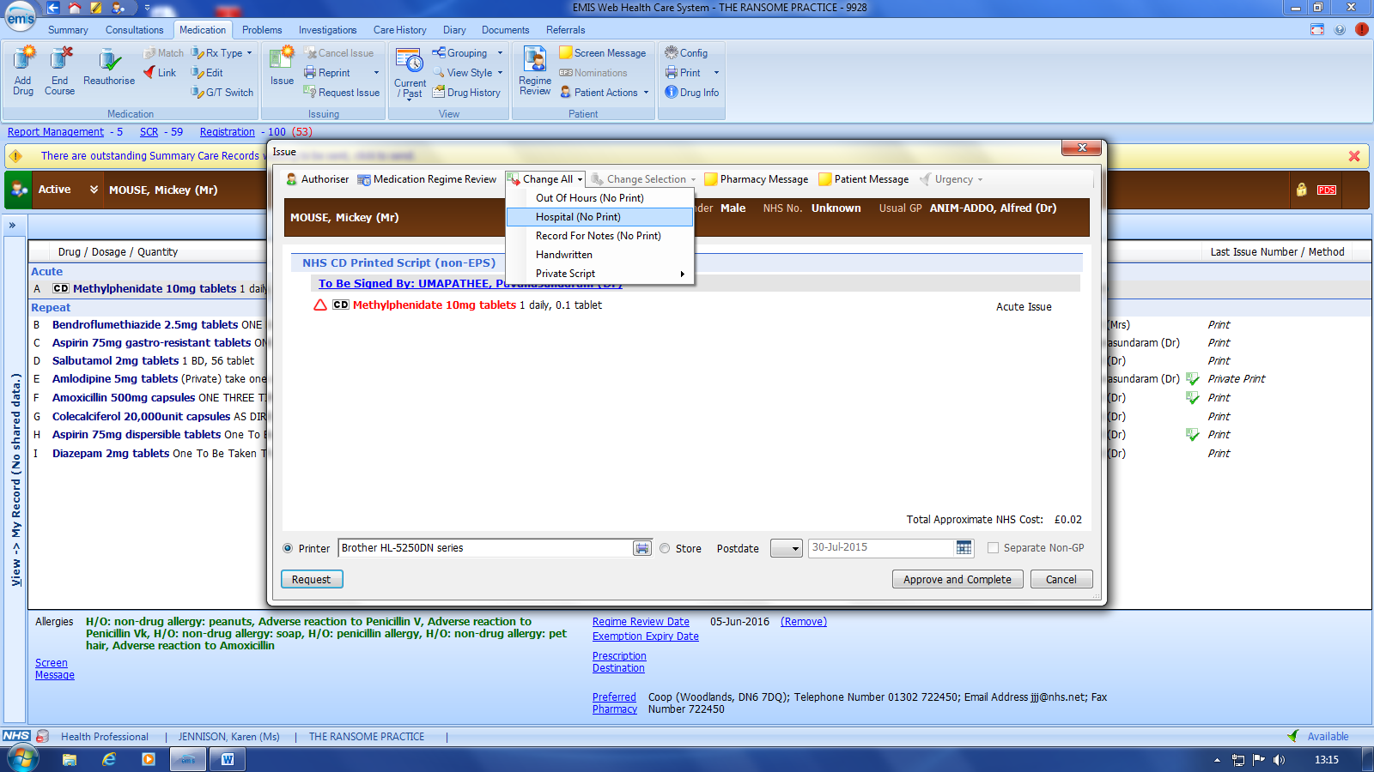

- Click Approve and complete

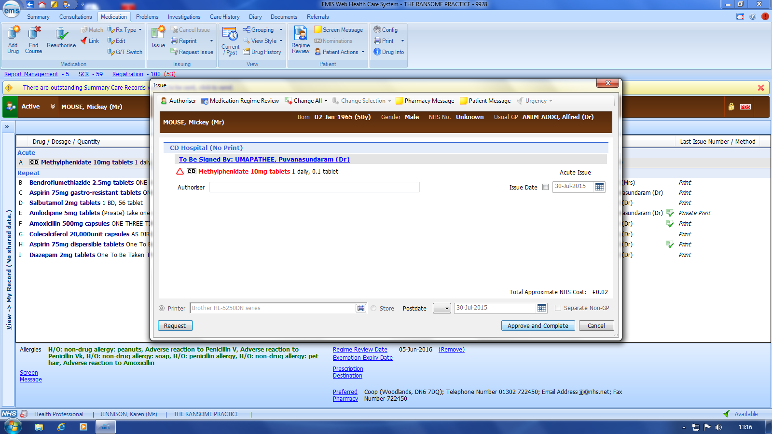

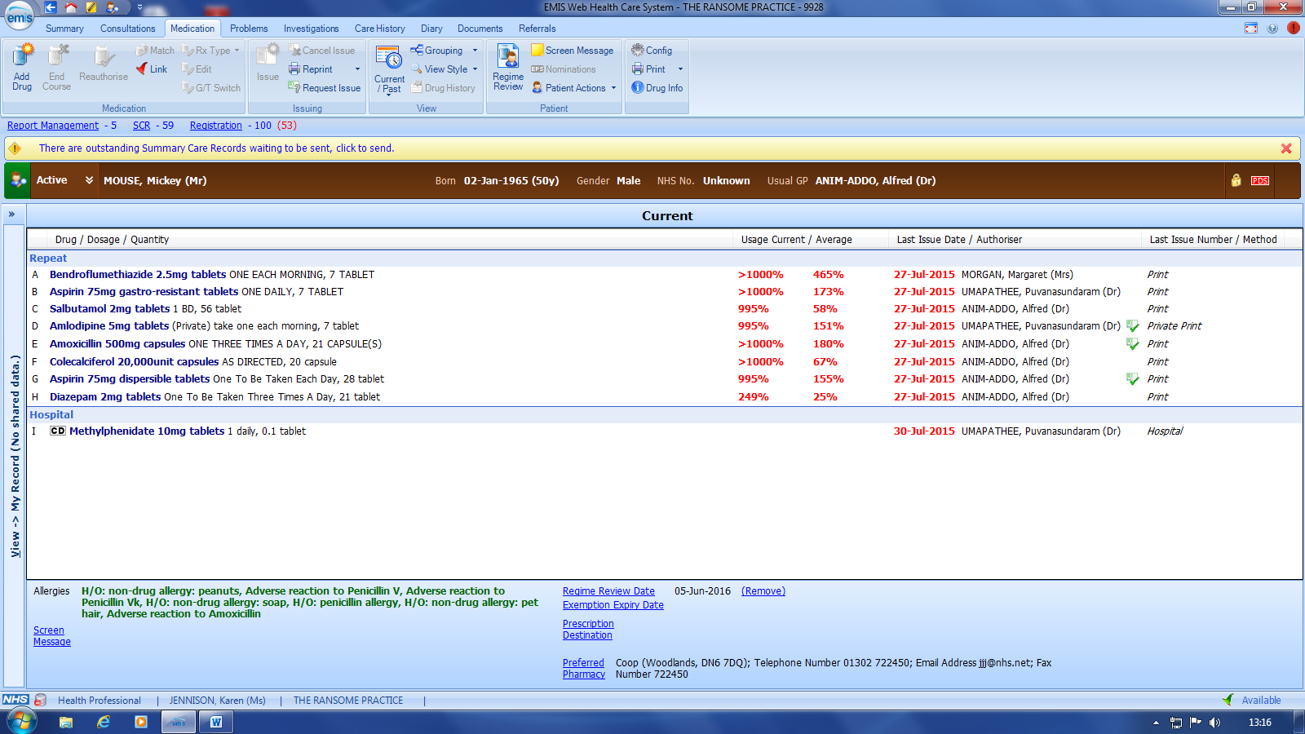

This is how it appears on medication record in a separate section below repeat

Systm1

1. Access patient care record on the clinical system
2. Click ‘medication’ – not repeat template

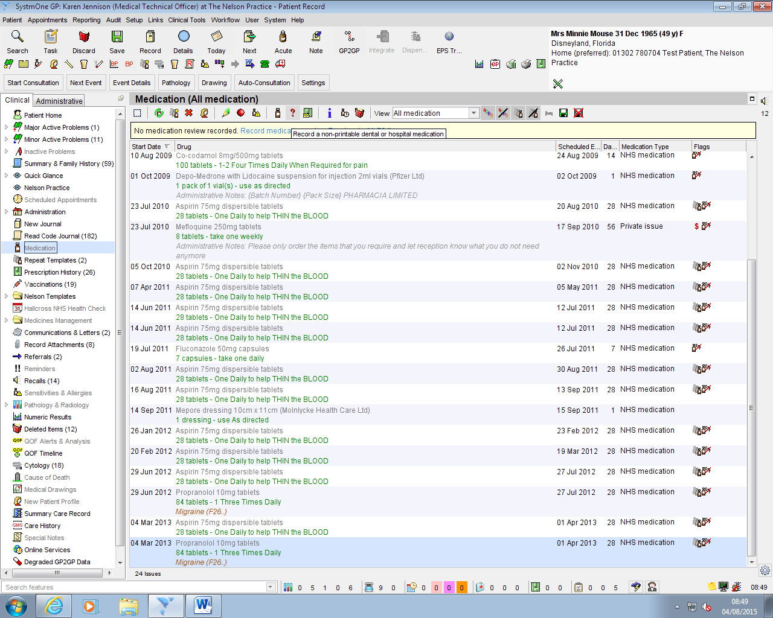
- Click the ? icon
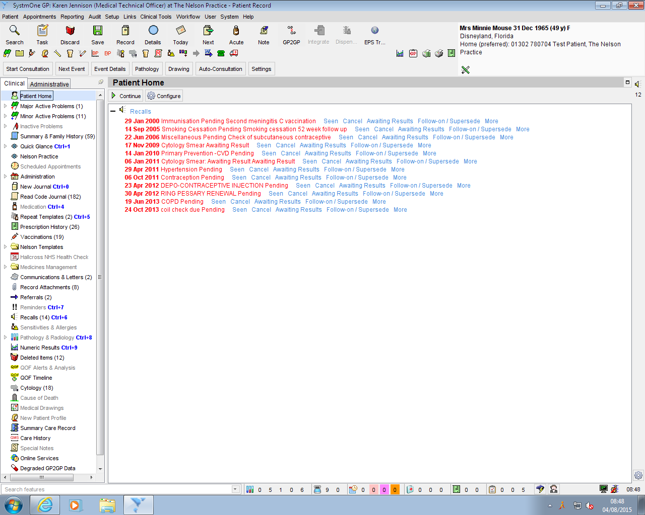
- Choose item and fill in information accordingly dose/quantity of 1 tablet and Script note:- Hospital prescription only
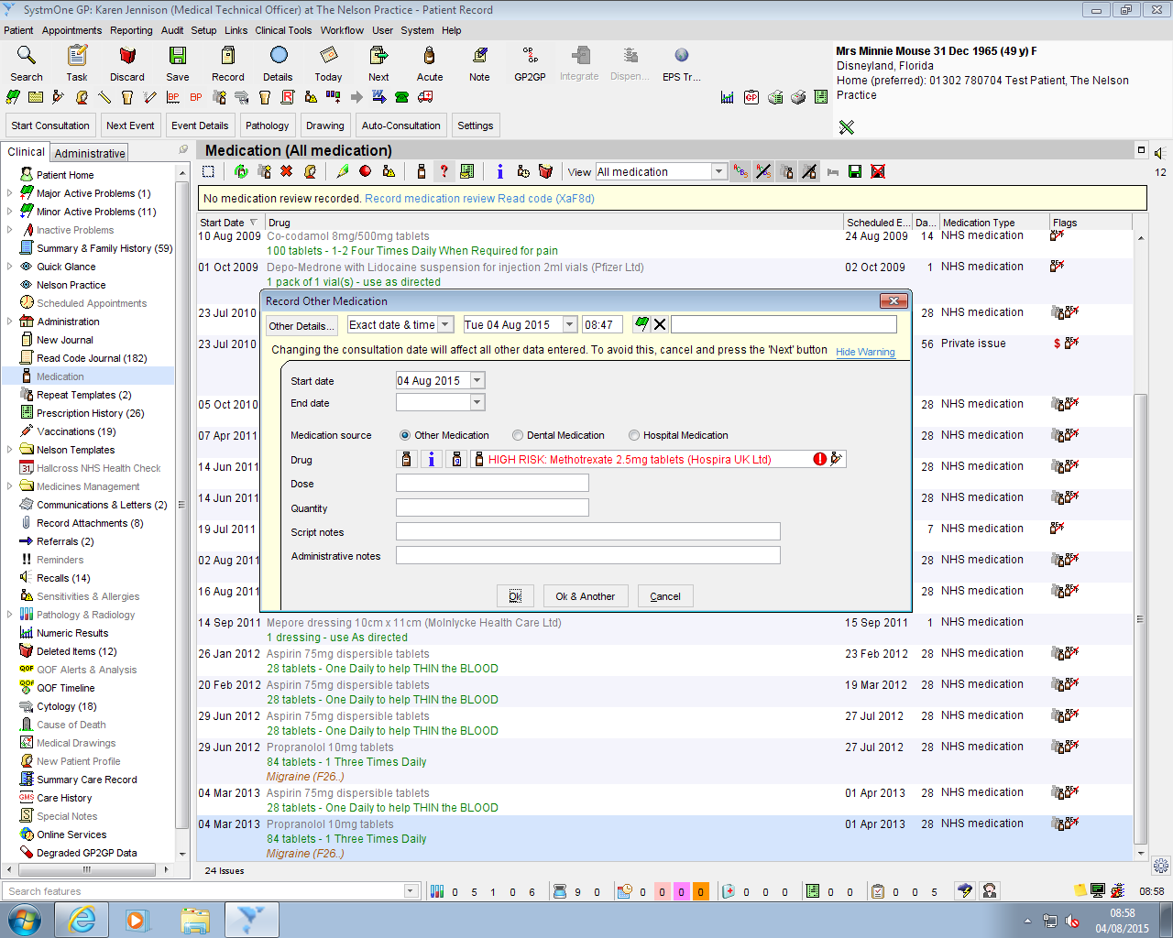
- Choose the medication source by clicking the appropriate circle eg Hospital medication
- Click OK

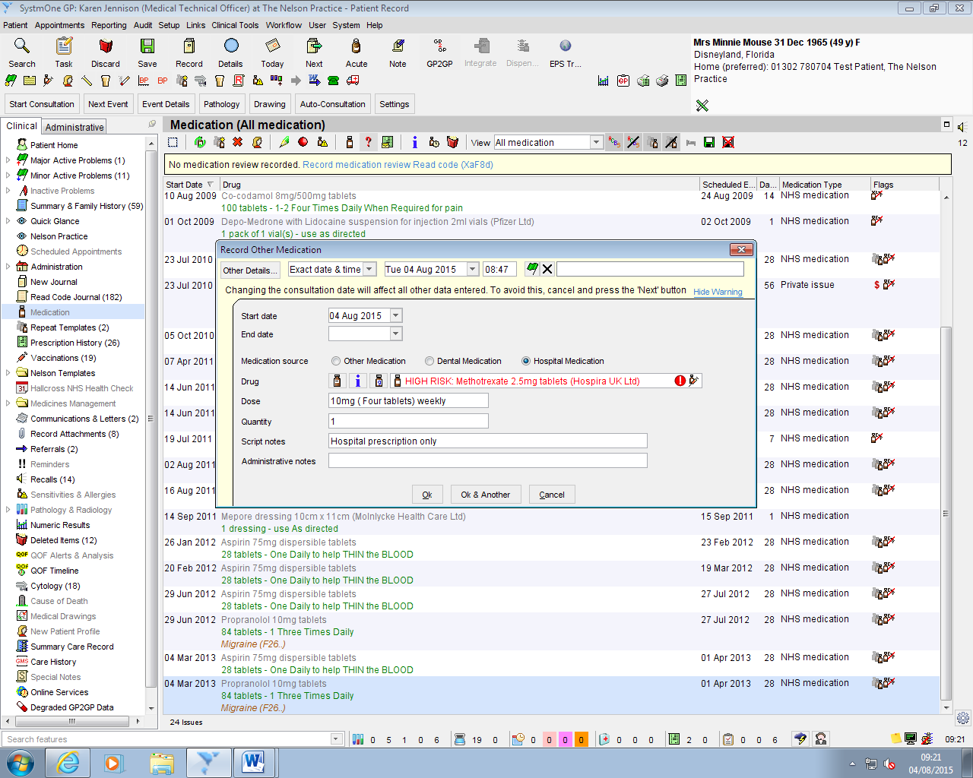
7. Click on repeat templates and the newly added medication will show at the bottom of the screen under ‘ other medication’ The hospital only item will appear with a large H under the flags section of the screen.
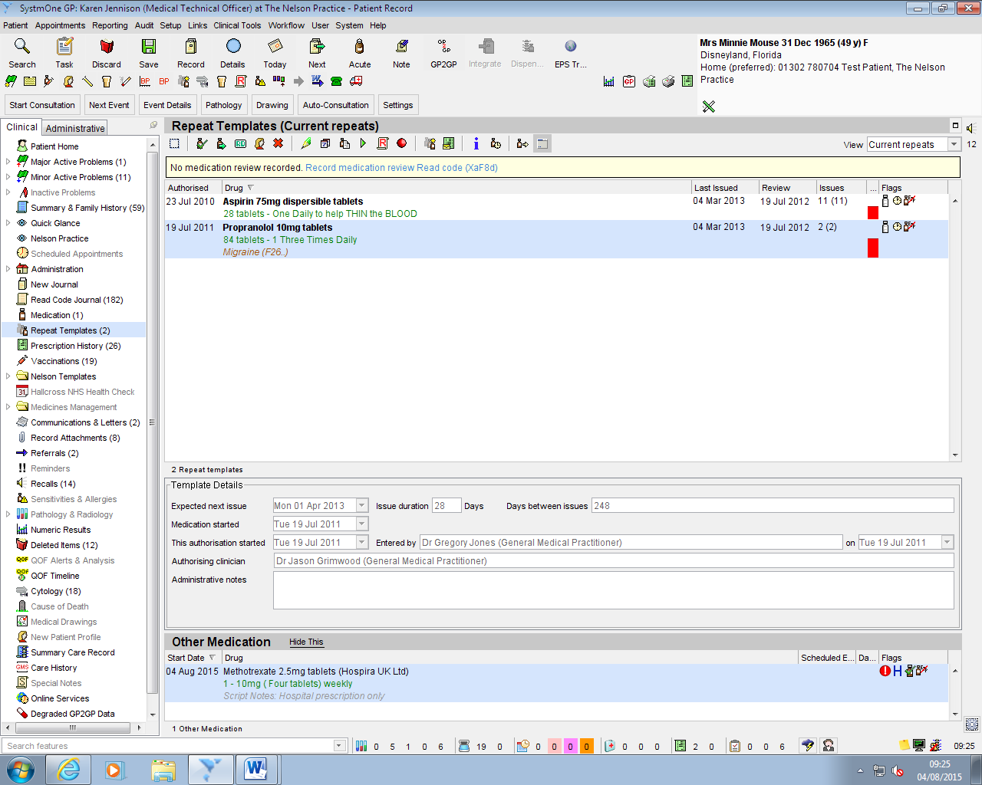
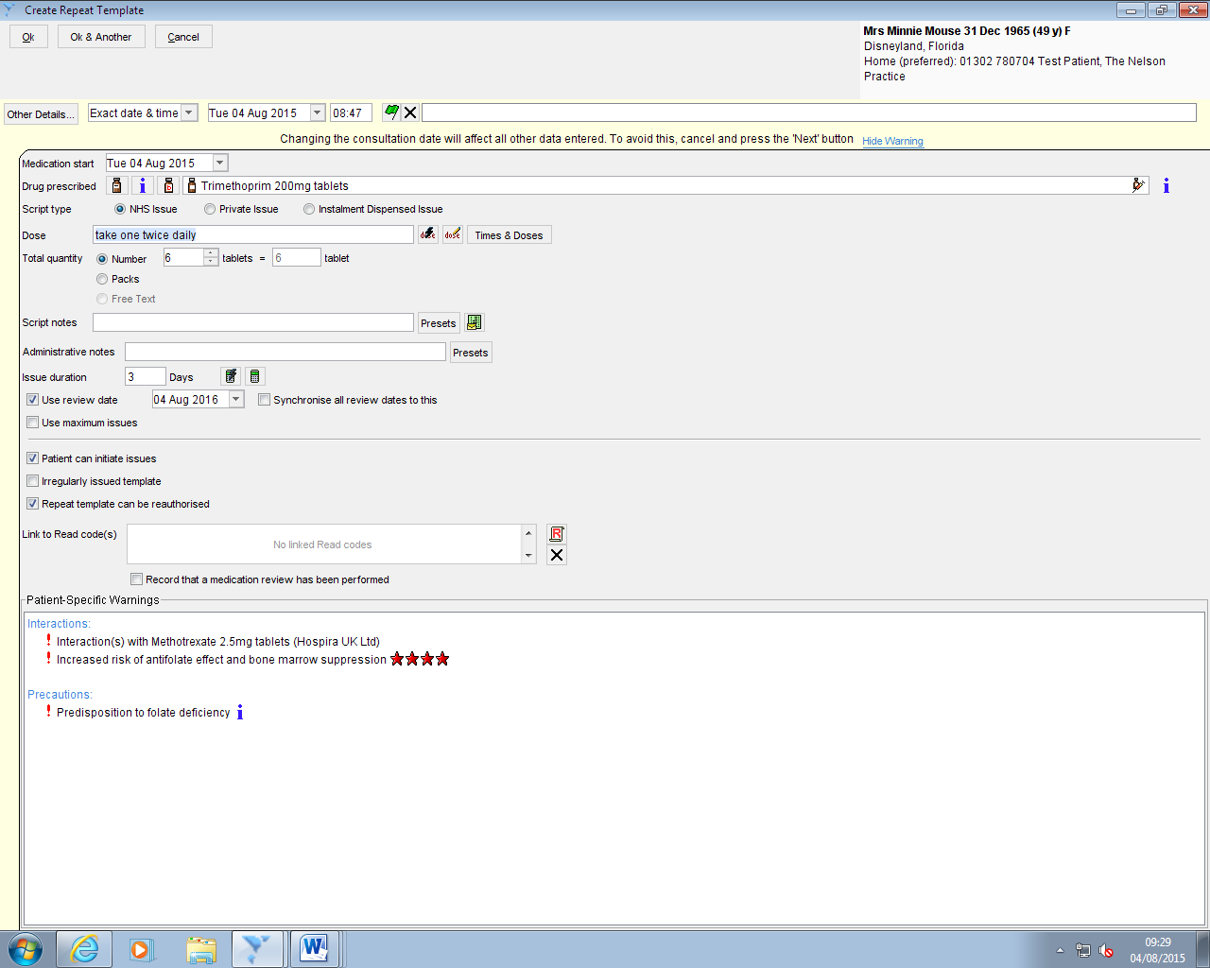
Now :- If Trimethoprim is prescribed the interaction warnings appear in the box called ‘patient specific warning’
Please note that if you cannot see the ‘other medication’, you can pull up the bar at the bottom of the screen to show the medication. Even if you cannot see it, the interaction will appear as an alert when another drug is prescribed.

